**Deploy the application to a Kubernetes cluster using kubectl**

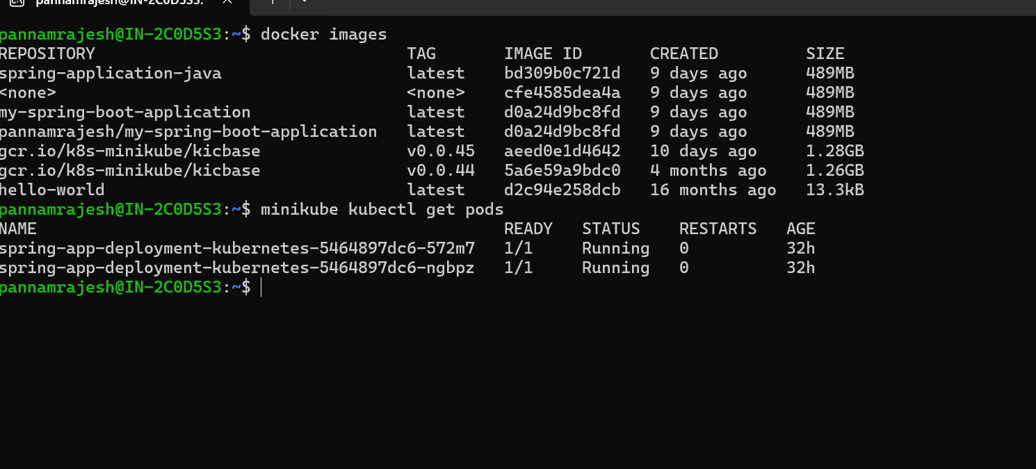

**Expose the application using a Kubernetes Service to access it external**

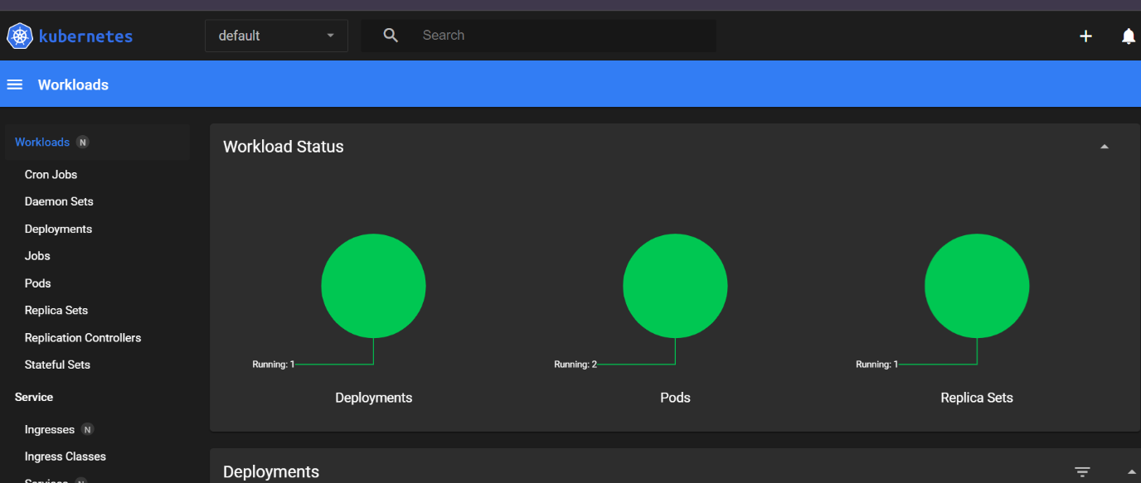

**Scale the application by increasing the number of replicas.**

